***Report on COVID 19***

***in Delhi and Uttar Pradesh (INDIA).***

**Area:** Delhi and Uttar Pradesh (INDIA)

**Domain Category:** COVID – 19

**Research Question:**

Is Number of New Cases of COVID-19 per day after Lock Down period in Delhi, India more than its Neighbouring state Uttar Pradesh, India?

**Resources**

**for Delhi** - https://github.com/imdevskp/covid-19-india-data/blob/master/complete.csv

**for Uttar Pradesh** - https://github.com/imdevskp/covid-19-india-data/blob/master/complete.csv

**VISUALIZATION:**

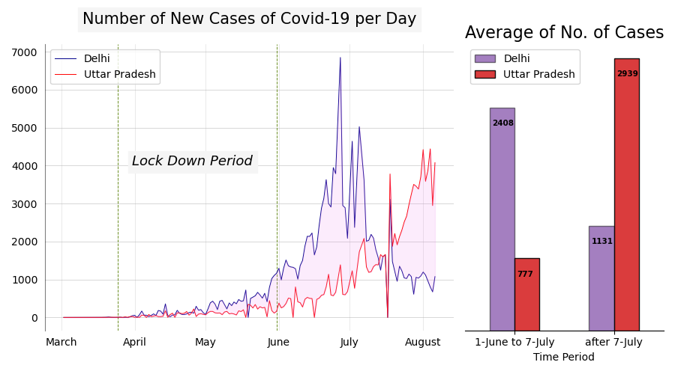

**CONCLUSION:**

The above visualization is concerned with the Increase or Decrease in Number of COVID-19 cases in Delhi and its neighbouring state Uttar Pradesh (India) for month March -2020 to August -2020.

In the Visualization, the Purple colour represent Delhi and Red colour represent Uttar Pradesh.

The area between two Green line specifies the Lock Down Period in India.

from the visualization, we all came to know that No. of cases per day gradually increases in Delhi in comparison to another state i.e., Uttar Pradesh after the lockdown in time period of 1-June to 7-July

and Decreases heavily after 7-July.

We can also observe that trend in Side Bar Graph,

as the average no. of cases per day for Delhi is 2408 and for Uttar Pradesh is 777 in time period of 1-June to 7-July.

but the situation Reverses tremendously after 7-july

as the average no. of cases per day for Delhi is only 1131, while for Uttar Pradesh is 2939.

**CODE:**

|  |
| --- |
| **EDA done by** |
| **Sandeep Singh Rawat** |
| ( [itzz.Sandeep.rawat@gmai.com](mailto:itzz.Sandeep.rawat@gmai.com) ) |
| <https://www.linkedin.com/in/sandeep-singh-awat/> |

<https://github.com/Sandeep-one/Covid-19/blob/main/covid.ipynb>